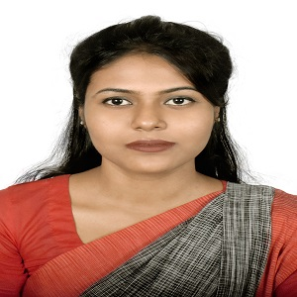
RESUME OF
MST. AREFA YEASMIN
Mailing Address:
Mst. Arefa Yeasmin
Lecturer,
Department of Food Engineering
Cell: +88 01784086811
E-mail: arefa.rima@bsmrstu.edu.bd

Employment History:
Lecturer,
Food Engineering (22 April, 2024 - Continuing)
Bangabandhu Sheikh Mujibur Rahman Science and Technology University, Gopalganj, Gopalganj Town Road, Gopalganj-8100, Bangladesh
Current monthly gross salary and other benefits: 9th Grade 22000-53060 BDT
Educational Qualification:

MS
Institute : Bangladesh Agricultural University, Mymensingh.
Department : Food Technology and Rural Industries
Passing year :2023
CGPA : 3.758
Merit position :1st
Thesis title : Mass Transfer and Physicochemical Changes in Osmotic Dehydrated Green Tomatoes
Fellowship : The National Science and Technology (NST) fellowship for conducting research during MS study.

B.Sc.
Institute : Bangladesh Agricultural University, Mymensingh.
Department : Food Technology and Rural Industries
Passing year :2020
CGPA : 3.592
Merit position :6th
Publication : Studies on Quality Parameters of Spinach Pasta; Journal of Agricultural Engineering.
Higher Secondary Certificate (H.S.C):
College : Govt. Azizul Haque College
Board : Rajshahi
Group : Science
Result : GPA- 5.00
Year of Passing : 2014

Secondary School Certificate (S.S.C):
School : Bogura Govt. Girls’ High School
Board : Rajshahi
Group : Science
Result : GPA-5.00
Year of Passing : 2012

Academic Activities:

⮚ 6-day long Extension Field Trip
⮚ One-month training at Training Institute and Chemical Industries (TICI)

Core Competence:
⮚ Excellent communication skill.
⮚ Disciplined & Responsible.
⮚ Flexible, hardworking & optimistic.
⮚ Capable to work under pressure.
⮚ Good team work capabilities

Language Proficiencies:
⮚ Fluent in Bengali & English
⮚ Working Knowledge in English
Computer Proficiencies:
- Proficient in using Microsoft Office (MS Word, MS Excel, MS Power point), Internet, Email etc.
- Able to analyze data statistically using statistical package program (Mini tab, SPSS)
Personal Information:
Name | :Mst. Arefa Yeasmin
Father’s Name | : MD. AZIZUR RAHMAN
Mother’s Name | : MST. NURUN NAHAR
Home District | : Bogura
Date of Birth | : 13/12/1997
Religion | : MUSLIM
Nationality | : Bangladeshi (By Birth)
Marital Status | : Unmarried
Blood Group | : AB (+)
Height | : 5'5"
Weight | : 56Kg

● Permanent Address: Village: NISHINDARA, KARBALA, Post Office: Bogura Thana: Bogura Sadar, District: Bogura.

References:

- Name: Dr. Poly Karmoker
Designation: Professor
Address: Dept. of Food Technology and Rural Industries
Mobile NO: 01308 060406
Email: poly.ftri@gmail.com

- Name: Dr. MD. Abdul Alim
Designation: Professor
Address: Dept. of Food Technology and Rural Industries
Mobile NO: 01732 252229
Email: maalim07@yahoo.com

Declaration of Authenticity:

I, the under signed declare that the information specified in this Resume is true to the best of my belief & knowledge & correctly describes my experience & myself.

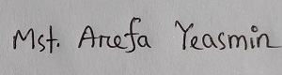

Signature

